Serenade – a brief history

Serenade, a 58-foot semi-traditional narrowboat, was built by
Pat Buckle in 1994, and has been well looked after – please
ask to see the maintenance history going back to 1999. To keep Serenade in top shape we aim to make a significant renewal or upgrade most years.

Our Boat Safety Scheme Certificate was last renewed in 2022.
A hull survey in June 2025 advised overplating of the baseplate will be required. When completed, the surveyor commented that Serenade will be “a well-appointed narrowboat with many years of life ahead of her”.

RECENT INVESTMENTS INCLUDE:

2013 | New carpet; 3 new radiators
2014 | New prop shaft; new battery charger; new cooker and grill
2015 | New skin cooling tank; new skeg; new lounge curtains
2016  2017  2018  2019  2020  2021  2022 | Bathroom bath replaced by shower unit  New floor in en-suite toilet & new toilet holding tank; all fluorescent lights replaced by LEDs; new fridge  New double glazed unit – front window; new toilet; hull survey  New deck boards & locker covers  Hull repairs; new rudder; new stern gear; new hatch lid; grit blast and 2-pack external repaint; 2-pack blacking (including baseplate); domestic electrical system upgrade including battery monitoring system  New mattress; new rear entry steps  Refurbished galley; new sofa bed and dinette upholstery; new rear door and frame; new domestic batteries; refurbished gearbox
2023 | New drive plate; new instrument panel box
2024  2025 | New diesel powered central heating boiler; new bathroom wash basin; new floor covering in galley & bathroom; new calorifier  New engine; repaint of engine bay and bow deck; new smart TV; new back-up switch to start engine using the domestic batteries

nb Serenade
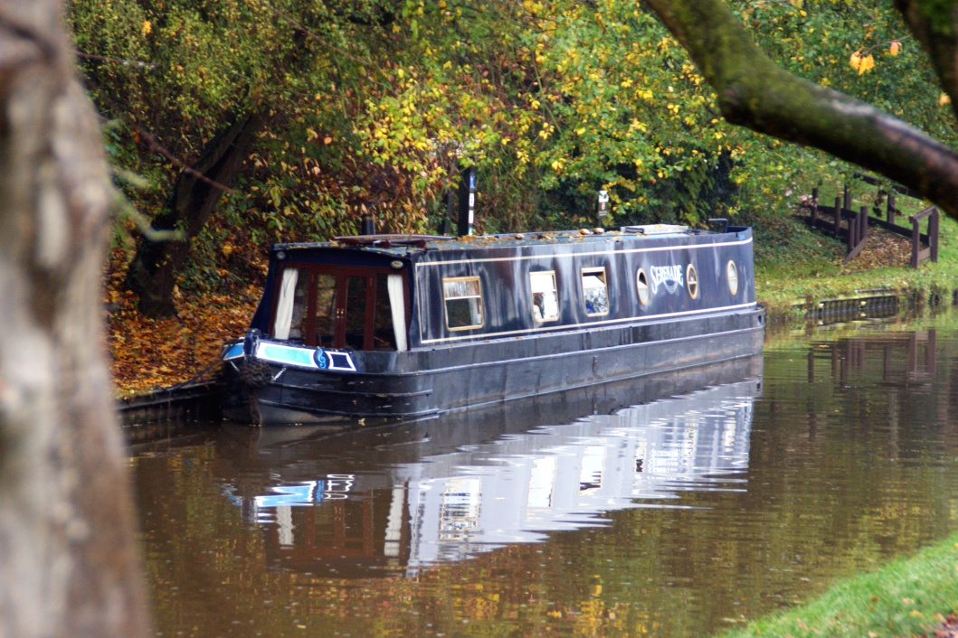

Information for prospective purchasers of shares

Please ask to see our Owners’ Manual and Syndicate Agreement for more information about nb Serenade and how our syndicate operates

Based at Wrenbury [Llangollen Canal] – changeover day Sunday

